**Decentralized ledger of accounting transactions**

**Blockchain technology**

Any technology is useful only if it solves some business problem, and Blockchain is no exception. There are several problems Blockchain solves.

**Trust**

When two parties execute an agreement, there are several moving parts. But what makes the transaction efficient is trust. If you agree to buy X number of widgets from me at a certain price, and we have established trust, the transaction goes smoothly. If not, then it gets complicated at best, and litigious at worst. There are many factors that establish an inherent trust like

* **Reputation** – If you are a reputable vendor, I am more likely to trust you.
* **History** – If we’ve been able to trust each other in the past, we are more likely to trust each other in the future.

Establishing trust between two parties can be very difficult, time-consuming, and largely subjective (you can’t really quantify “reputation” for example), and the larger the network involved in a transaction, the more difficult it is.

**Transparency**

In our fictional deal, you have your ledger to record various aspects of the transaction and I have mine. But I don’t see your ledger and you don’t see mine. Thus by its nature the deal is opaque, so we will probably have a contract to govern the terms of the deal. And other than the terms of the contract, that’s as transparent as the deal gets.

Since there is no transparency, it’s difficult to tell how things are going until the deal is done.

What happens if something goes wrong? Let’s say I don’t hold up my end of the deal (or vice-versa)?

**Accountability**

To ensure the deal goes smoothly, you and I will probably deal with middlemen:

•    **Lawyers** – To draw up a contract, and if necessary provide legal services should things get litigious.

•    **Accountants** – To keep the ledgers, and ensure the exchange of goods (and money) goes according to the contract, and is properly recorded.

•    **Government** – In some industries, there are government regulations and oversight mandates and other guidelines that have to be followed.

The main idea of the project is creating decentralized ledger of transactions, which give trust, transparency and accountability of all operations.

**Signed receipt**

To realize this we need to implement **signed receipt concept.** Within the full record of the signed receipt, the user's intention is expressed, and is fully confirmed by the counterparty’s response. Both of these are covered by digital signatures, locking these data down. A reviewer such as an auditor can confirm the two sets of data, and can verify the signatures.

The digitally signed receipt, with the entire authorization for a transaction, represents a dramatic challenge to double entry bookkeeping at least at the conceptual level. The cryptographic invention of the digital signature gives powerful evidentiary force to the receipt, and in practice reduces the accounting problem to one of the receipt's presence or its absence. This problem is solved by sharing the records - each of the agents has a good copy in blockchain.

In some strict sense of relational database theory, double entry book keeping is now redundant; it is normalized away by the fourth normal form.

Which leads to the pairs of double entries connected by the central list of receipts; three entries for each transaction. Not only is each accounting agent led to keep three entries, the natural roles of a transaction are of three parties, leading to three by three entries.

We term this *triple entry bookkeeping*. Although the digitally signed receipt dominates in information terms, in processing terms it falls short. Double entry book keeping fills in the processing gap, and thus the two will work better together than apart. In this sense, our term of triple entry bookkeeping recommends an advance in accounting, rather than a revolution. (pls. see <http://iang.org/papers/triple_entry.html>)

**Realization**

To test the main concept we are going to implement idea in the Ethereum eco-system by creating of signed receipts using the smart contracts.

All funds transferring transactions of Decentralized Autonomus Organisation should be done using the smart contract.

Smart contract – **signed receipt** which hold all required information for each transaction:

* DAO address of seller
* DAO address of customer
* Date and time of each stage of transaction
* Contract / Agreement (Basis of operation)
* Nature of transaction (Description of product or service)
* Amount in ETH
* Type of operation – required criteria to build account entry
* XBRL code of transaction for seller
* XBRL code of transaction for customer

This information can be mined and collected to build financial statements of the Company (DAO). Example of smart contract work-flow for DAO presented below:

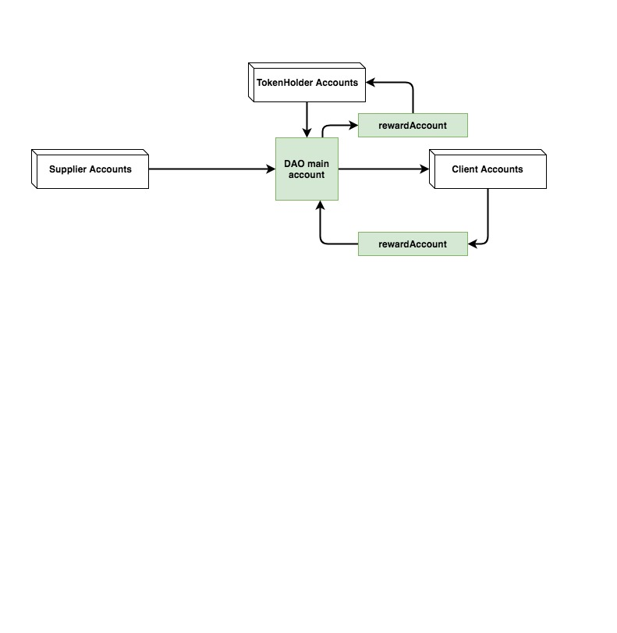

pic.1 *DAO investing in real assets*

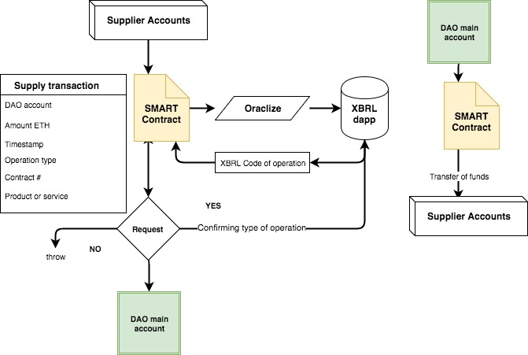

pic.2 *Smart contract workflow.*

Example:

DAO “Car for rent” decided to buy 5 Tesla car.

1. Supplier sold cars and signed the receipt in the form of smart contract. Supplier provide:
   1. DAO account of customer;
   2. Agreement #;
   3. Amount in ETH;
   4. Description of cars;
   5. Type of operation: Realization of tangible assets
2. Smart contract register time of operation and request from external service XBRL code of operations.
3. Smart contract request from the DAO to confirm the type of operation and the terms of agreement. For example payment within 5 working days.
4. After the 5 working days DAO will transfer the funds to supplier using the smart contract.

At the end we have signed receipt in the form of smart contract in blockchain of Ethereum containing all accounting information giving transparency and accountability of DAO.

**Why this is important**

This project and implementation of smart contract in transaction between Decentralized Entities defend interest of investors by giving them:

* financial information from decentralized sources free from bias and fraud;
* possibility to evaluate and compare DAOs and token issued;
* increase of creditability and reputation of DAO.